Monday, November 13th, 2017
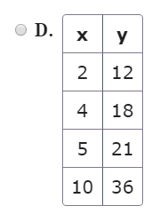
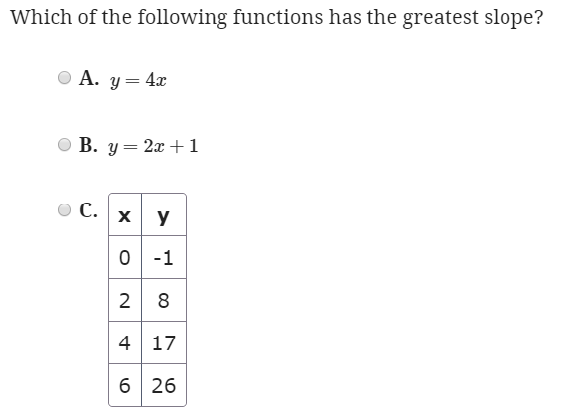

Tuesday, November 14th, 2017
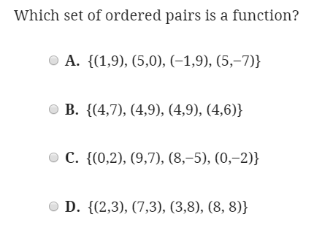

Wednesday, November 15th, 2017
In what ways can we finish the table so it is a function? Describe the requirements for each empty spot.
X | Y
6 | 2
-4
17 | 6
 | 7
39

Thursday, November 16th, 2017
Observe the graph of the relationship between x and y. Select all statements that are true.
