Monday, October 30th, 2017
Solve each equation for the indicated variable.
1. $6rp+2v=y$ (Solve for $p$) 2. $\left(\frac{6}{13}c\right)+15=h$ (Solve for $c$)

Tuesday, October 31st, 2017
Solve each equation for $h$. Then evaluate using the given variables.
1. $A=\frac{1}{2}bh$ 2. $p=qr-fh$

Evaluate when $A=10$ and $b=4$ Evaluate when $p=25, q=2, r=5, and f=3$

Wednesday, November 1st, 2017
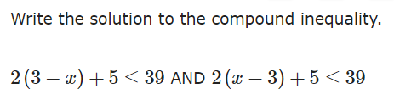

Thursday, November 2nd, 2017
