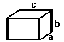
Monday, October 23rd, 2017
Determine the surface area of each rectangular prism.
$Surface Area=2ab+2bc+2ac$
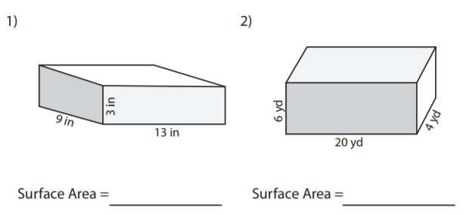

Tuesday, October 24th, 2017
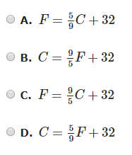
Crystal’s teacher gives her the following steps to convert a temperature from Celsius (C) to Fahrenheit (F):
1. Multiply the degrees in Celsius by 9.
2. Divide the product by 5.
3. Add 32.
Which formula matches these steps?

Wednesday, October 25th, 2017
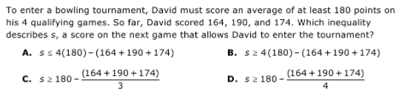

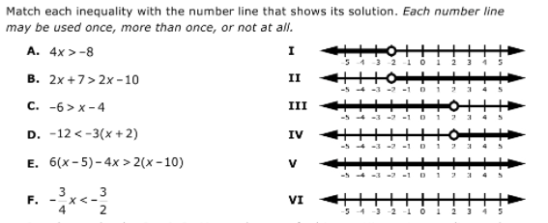

Thursday, October 26th, 2017
