Monday, April 9th, 2018
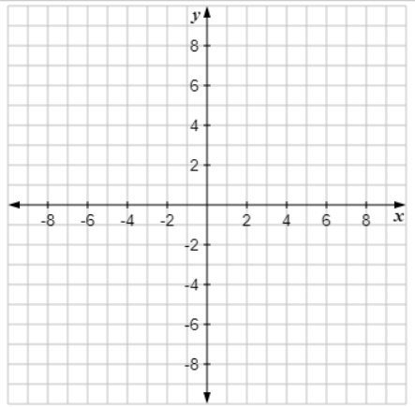
Solve the following system of equations using a graph:
$5x – 3y = 18$ and $x + 2y = 14$

The solution to the system is x = ______ and y = ______.
Tuesday, April 10th, 2018
Solve the following system of equations using a graph:
$y=3x-8$ and $2y-6x=-16$

The solution to the system is x = ______ and y = ______.

Wednesday, April 11th, 2018
Solve the following system of equations using a graph:
$y=3x-8$ and $3y-9x=15$

The solution to the system is x = ______ and y = ______.
Thursday, April 12th, 2018
Solve this system of equations by graphing, and then fill in the blanks below.
$4x - 2y = 14$ and $11x + y = 6$
The solution to the system is the point (______, ______).

