Monday, January 29th, 2018
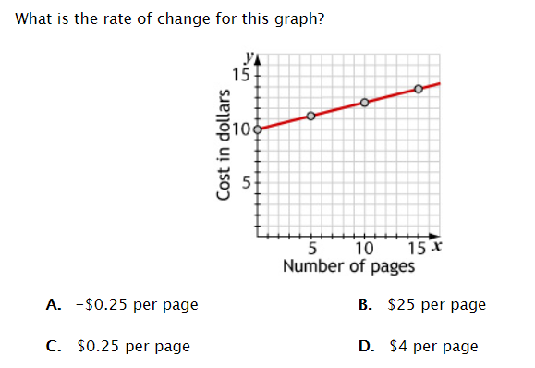

Tuesday, January 30th, 2018
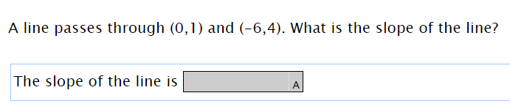

Wednesday, January 31st, 2018
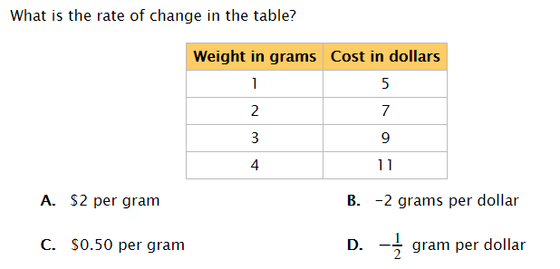

Thursday, February 1st, 2018
Joe is saving money for a bike. He plans on saving the same amount each week. By week 4, he has $110 and by week 8 he has $190.
How much money does Joe save each week for his bike?

