Monday, January 22nd, 2018

Tuesday, January 23rd, 2018
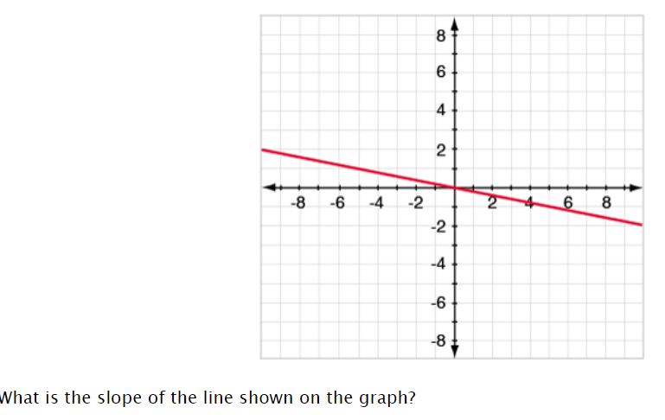

Wednesday, January 24th, 2018
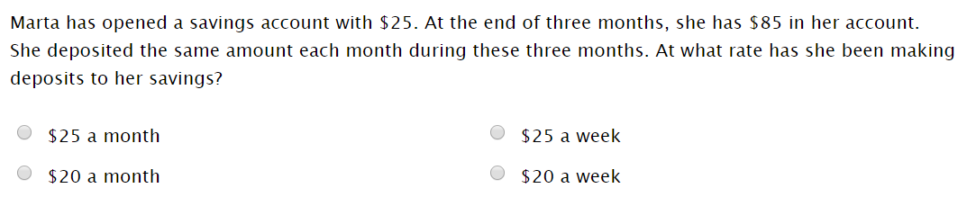

Thursday, January 25th, 2018
