Monday, November 27th, 2017
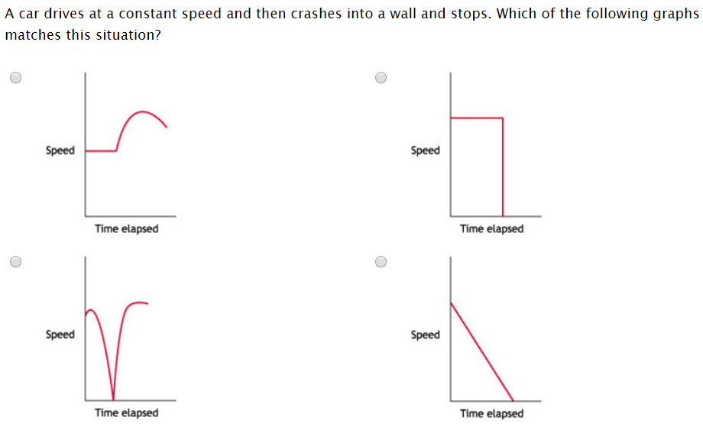
Tuesday, November 28th, 2017
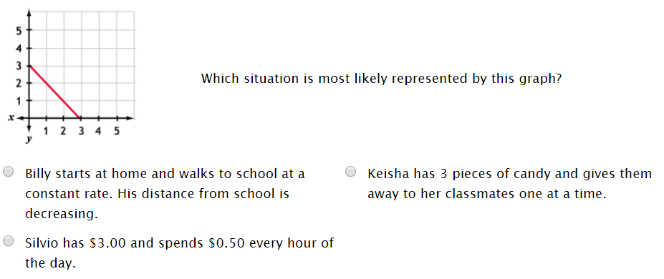

Wednesday, November 29th, 2017
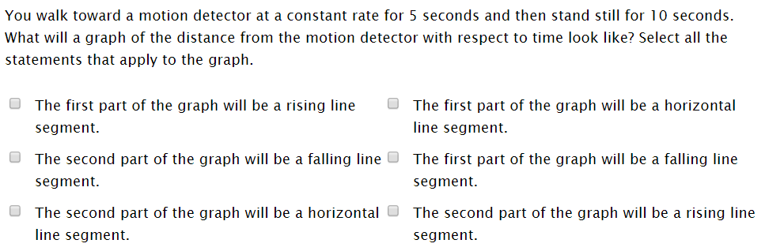

Thursday, November 30th, 2017
