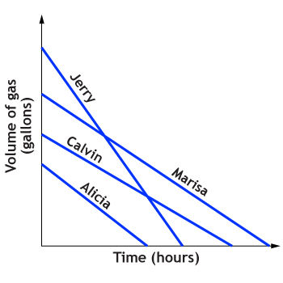
Jerry, Alicia, Calvin, and Marisa wanted to test their cars' gas mileage. Each person filled his or her car's gas tank to the maximum capacity and drove on a test track at 65 miles per hour until the car ran out of gas. The graph shows how the amount of gas in the cars changed over time.
- Whose car has the largest gas tank? Explain your reasoning.

- Whose car ran out of gas first? Explain your reasoning.

- Whose car traveled the greatest distance? How does knowing that they all traveled at 65 miles per hour help you know who traveled the greatest distance?

- Determine whose car gets the worst gas mileage. Describe how you used the graphs to make your decision.

- How are Calvin’s graph and Marisa’s graph similar and how are they different in terms of the given situation?

