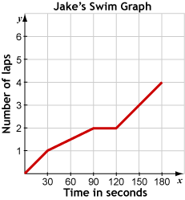
Topic 5: Analyzing Graphs
1. The graph shows the number of laps Jake swims over time. Precisely describe how the number of laps changes over the time period shown in the graph.

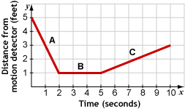
Topic 6: Exploring Rate of Change in Motion Problems
2. Based on the graph, how far away was Terrance from the motion detector at the beginning?

3. What is the rate of change during A?

4. What is the rate of change during C?

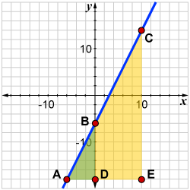
5. Which of the following statements about the graph are true? Select all that apply.
a. $∆ADB$ and $∆AEC$ are similar.
b. $∆ADB$ and $∆AEC$ are congruent.
c. Both $∆ADB$ and $∆AEC$ can be used to find the slope of $\overline{AC}$.
d. There are triangles other than $∆ADB$ and $∆AEC$ that can be used to find the slope of $\overline{AC}$.
e. Using $∆ADB$ to find the slope of the line will be different than using $∆AEC$.

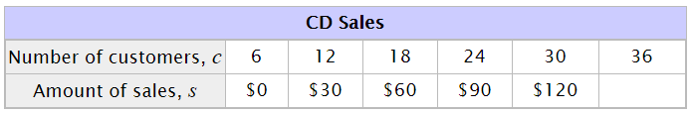
Topic 7: Linear Patterns and Functions
6. The input/output table below represents a linear function. What is the output when the input is 36?

Topic 8: Understanding Slope and Y-Intercept
7. Natalie and Raul recently had a rectangular pool installed in their backyard. To repair the pool, Raul pumps water out of the pool at a rate of 200 gallons per hour. (Remember that the pool holds 1700 gallons of water when full.) Which representations model this situation? Select all that apply.
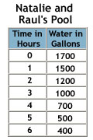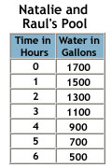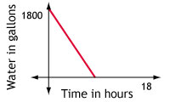
$w=1700-200h$, where $w=$water remaining and $h=$ time in hours
$w=200-1700h$, where $w=$water remaining and $h=$ time in hours

Pattern ($n$) | Hexagons ($t$)
1 | 7
2 | 10
3 | 13
8. Courtney made this hexagon pattern. What equation will tell you how many total hexagons (t) are needed for any given pattern number (n)?
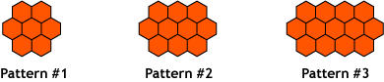

9. What does proportional look like…
In a table?
In a graph?
In an equation?
In a situation?
10. The table contains x and y values of points that lie on a line. Which statements correctly describe his line? Select all that apply.
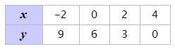
a. The slope of the line is $\frac{2}{3}$. b. The slope of the line is $-\frac{3}{2}$.
c. The slope of the line is $2$. d. The slope of the line is $3$.
e. The y-intercept of the line is $6$. f. The y-intercept of the line is 4.

Unit 9: Exploring Bivariate Data
11. Cici surveyed the students in her team about the pets they have at home. Of the 63 students who own a dog, 1/3 do not own a cat. Of the 34 students who do not own a dog, 16 do have a cat. Use this information to complete the two-way table.
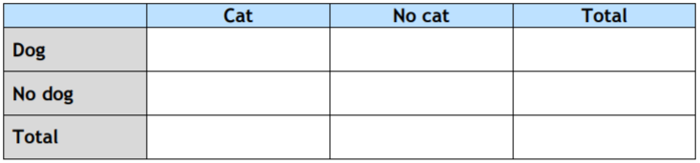

12. Cici now wants to know if there is a relationship between those who own cats and dogs. Do you think there is evidence that those who own a dog own a cat? Support your answer using data from the table.

