Robert works in a factory that manufactures parts. He thinks that as the machines in the factory get older, they make fewer parts each day. He collects the following data to see if he is correct.
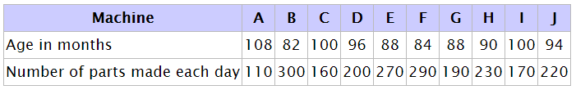
Robert plots the number of parts made each day against the age of each machine.
1. The data for the first five machines, A to E, has been plotted for you. Plot the points for the rest of the machines.
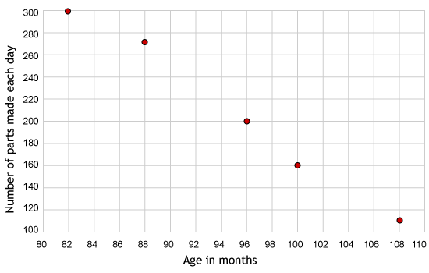
2. Draw a straight line that best fits the points plotted.

3. How many parts would Robert expect a 104-month-old machine to make?

4. The company decides to scrap machines when they can no longer produce at least 250 parts each day. Use the graph to estimate the probable age of a machine that produces 250 parts each day.

