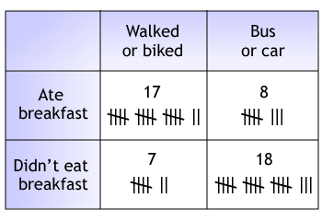
Leila walks to school. She always makes sure to eat breakfast so she isn’t hungry at school. Leila wonders if students who walk or bike to school eat breakfast more than students who take the bus or get a ride in car. As part of a science fair project on exercise and caloric consumption, Leila interviewed 50 classmates about how they got to school that day and whether or not they ate breakfast that day. Below are her survey results.

a. Build a two-way table showing the data Leila gathered. Then find the frequencies of each cell relative to the total number of students in the survey.

b. Of the students who walked or biked to school that day, what percent ate breakfast and what percent did not eat breakfast?

c. Of the students who took the bus or got a ride in a car that day, what percent ate breakfast and what percent did not eat breakfast?

d. Of the students who ate breakfast, what percent walked or biked to school and what percent rode the bus or got a ride in a car?

e. Of the students who did not eat breakfast, what percent walked or biked to school and what percent rode the bus or got a ride in a car?

f. Describe an association you see in the data.

