Part 1: Real Numbers (Rational/Irrational Numbers, Square Roots)
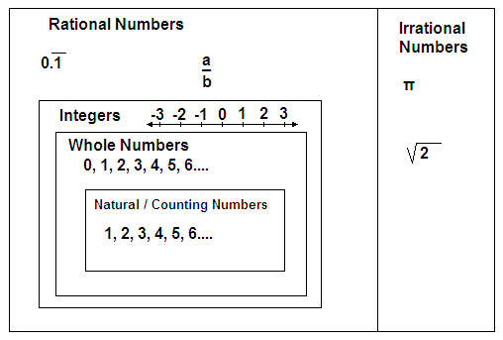
1. Which fraction is equivalent to $0.5\overline{21}$?
$$\frac{521}{999}$$ | $$\frac{705}{990}$$ | $$\frac{5205}{9990}$$ | $$\frac{258}{495}$$ | $$\frac{615}{990}$$

2.
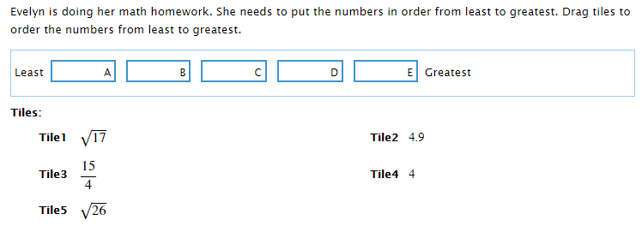
3.
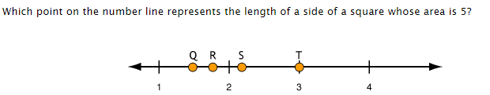
Q | R | S | T

4. Convert $0.\overline{381}$ to a fraction in simplest form.

5.
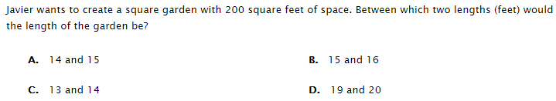
6.
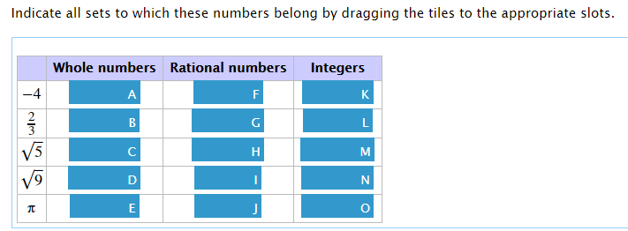
7.
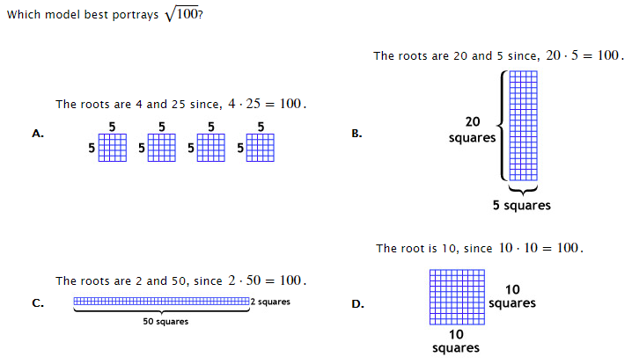
Part 2: Exponents and Scientific Notation
8.
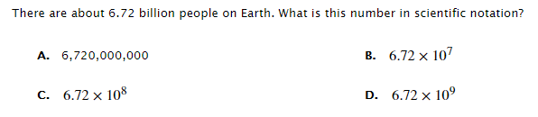

9. Maggie is trying to solve a homework problem. She has to arrange numbers that are expressed exponential form. Place the number in order from least to greatest.
${10}^{6}$, ${10}^{12}$, ${10}^{-3}$, $0$, ${10}^{-5}$, ${10}^{2}$, and ${10}^{5}$

10.
11.
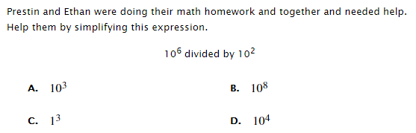
12.
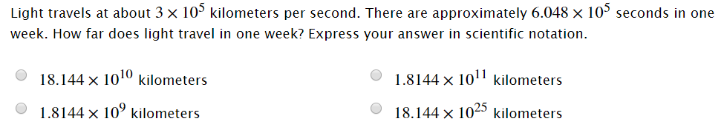

Part 3: Pythagorean Theorem
13.
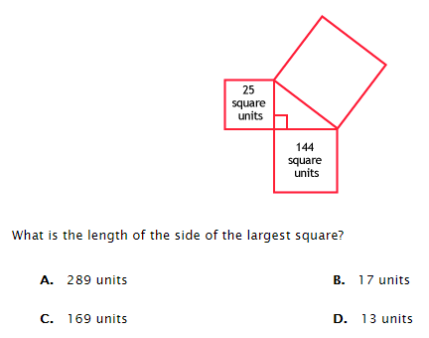
14.
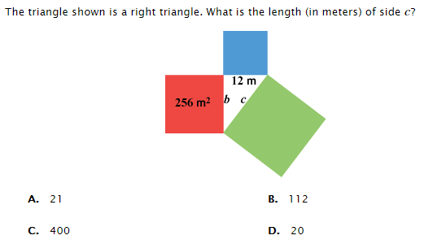

15. What is the distance between $\left(-3,0\right) and \left(2,-4\right)?$

