Monday, November 6th, 2017
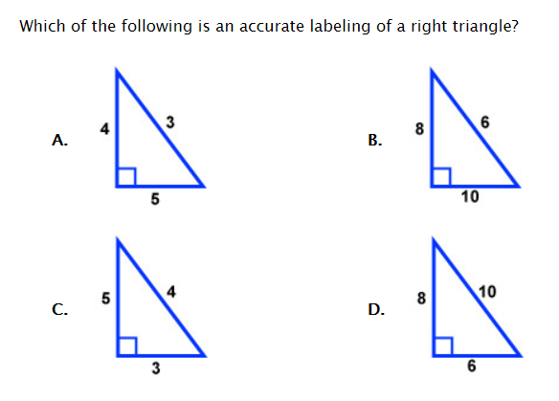

Wednesday, November 8th, 2017
1. Find the length of the hypotenuse of a right triangle with legs of 5 cm and 6 cm.

2. A garden plot is in the shape of a right triangle. The right triangle has a hypotenuse of 10 feet and one leg that is 7 feet long. How long is the other leg of the triangle?
10 feet
7 feet

Thursday, November 9th, 2017
Thad has a ladder that is 16 feet long. To get the correct height, he adjusts the distance between the base of the ladder and the wall.
a. If he places the base of the ladder 8 feet from the wall, how high up the wall will the ladder reach? Draw a diagram to support your work.

b. If he places the base of the ladder 6 feet from the wall, how high up the wall will the ladder reach? Draw a diagram to support your work.

