Monday, April 23rd, 2018
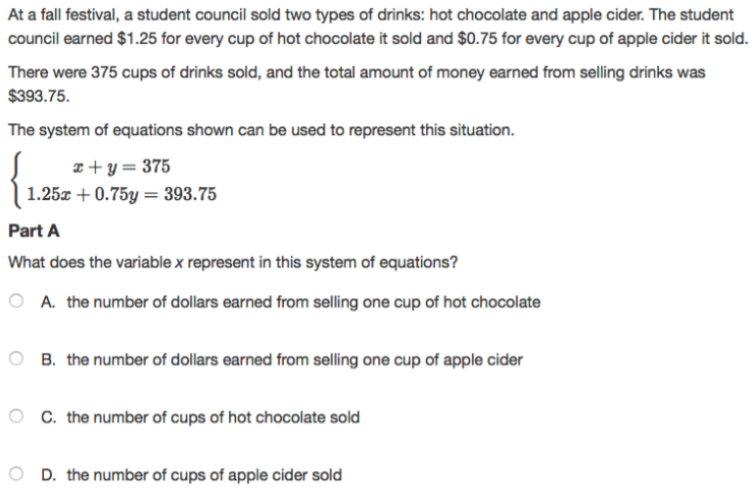

Tuesday, April 24th, 2018
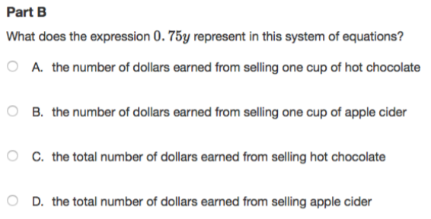
Wednesday, April 25th, 2018
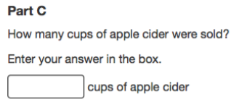

Thursday, April 26th, 2018
