**Monday, April 16th, 2018**

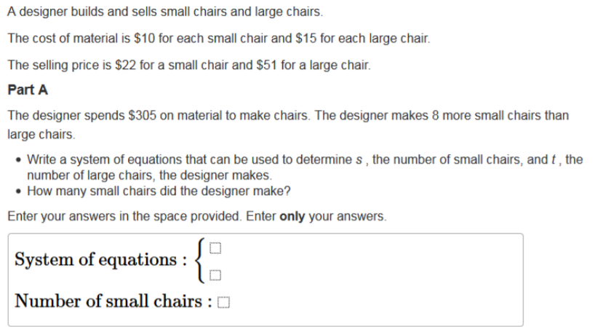

**Tuesday, April 17th, 2018**

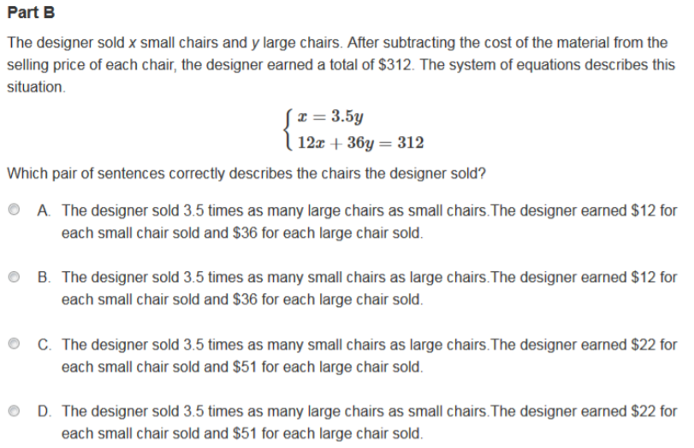

**Wednesday, April 18th, 2018**

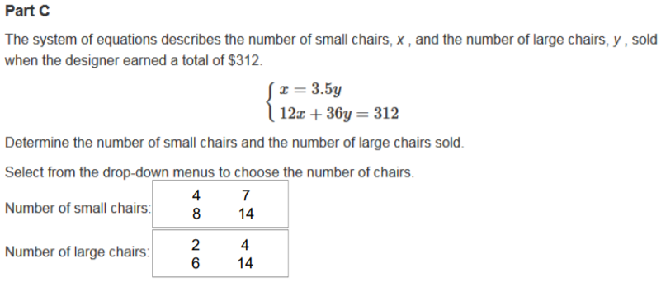

**Thursday, April 19th, 2018**

