Tuesday, April 3rd, 2018
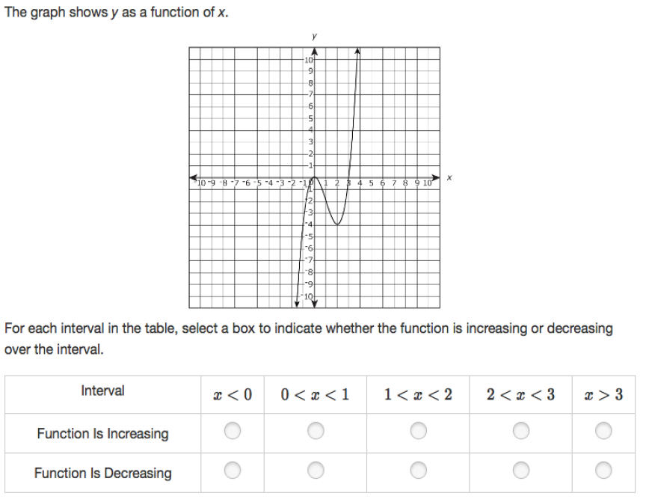
Wednesday, April 4th, 2018
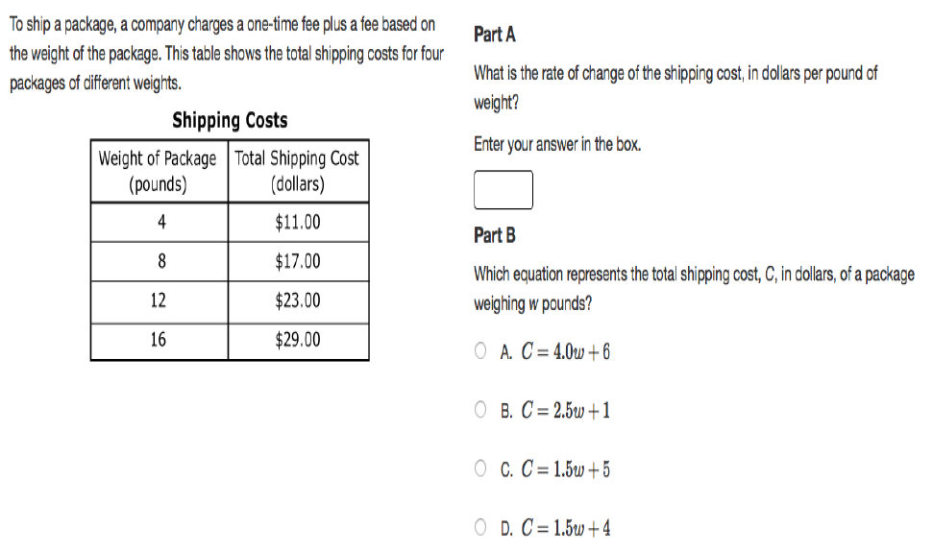
Thursday, April 5th, 2018
