**Monday, December 4th, 2017**

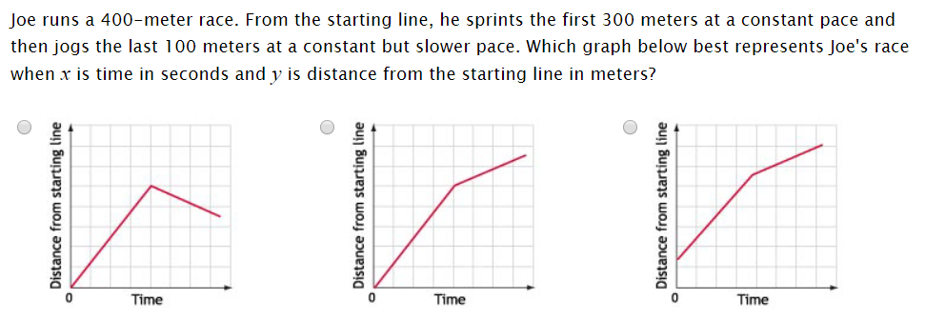

**Tuesday, December 5th, 2017**

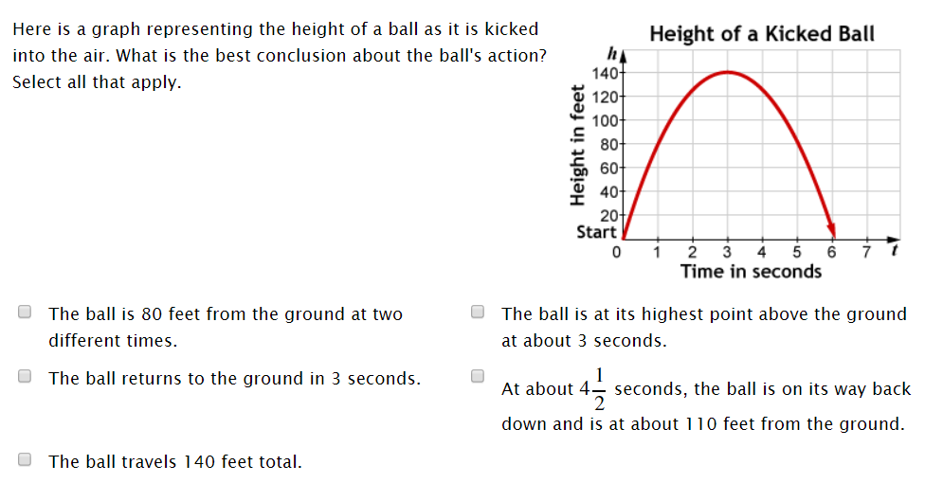

**Wednesday, December 6th, 2017**

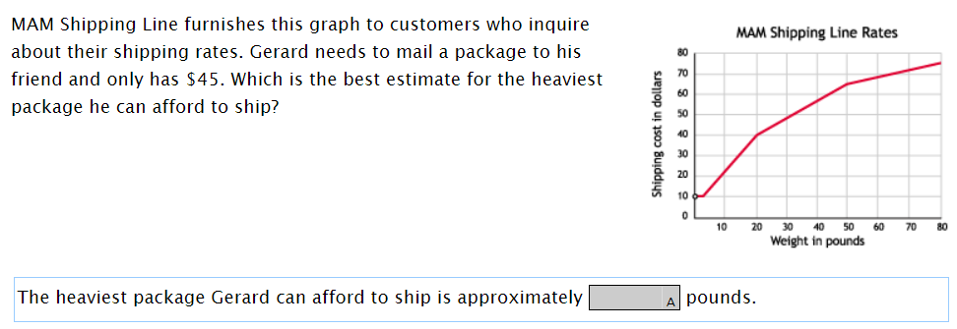

**Thursday, December 7th, 2017**

