1. A carpenter is getting ready to lay flooring down in a house. The family room is set up by the expression (4x-3)(4x). The length is 4x. State all information about the expression including: width, length, the comparison between width and length.

2. Surface area is 2HL+2HW+2WL. Label the width, length, and height of the given expression:
2(5x+1)(3x) + (10x+2)(4x) + 24x²

3. Jimmy and Sophie went to the store. Jimmie went and bought a shirt for $8 and 13 pairs of socks at the same price and spent $34. Sophie bought a shirt for $5 and 3 pairs of pants for the same price and spent $65. Write an equation for both Jimmy and Sophie.

4.
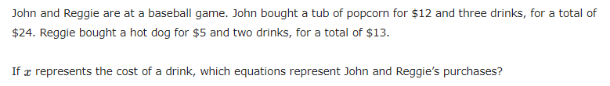

5.
Joe uses a 3D printer to create plastic sculptures that he sells at a local craft fair. He bought the 3D printer for $1,500. Each sculpture he makes uses approximately $10 in plastic material.
Joe plans to sell each sculpture for $25.
What does the equation 25s=1,500+10s mean in this context?

What represents dollars?
What represents sculptures?
What represents dollars per sculptures?

6. A man walks into a store and buys apples and bananas. He buys a total of 12 apples and bananas. Each bag of apples is $6 and the bananas are $3. He spends a total of $24. A woman goes into the store and buys a bag with both apples and bananas for $8 and spends a total of $24. Write all possible equations.

7. The clubs are having a Halloween candy exchange. Each person must bring in enough candy for every person in the club except themselves but including the club leader. Write an expression for six clubs with the same number of participates in each club.

8. Jamie delivers pizza for $12 an hour. Jamie has to pay $3 an hour for gas and puts $5 into a college saving account. Write an equation that can be used to find a profit of $31.

9. Are the given expression equivalent?

(3x+2)² - (3x-2)² and 24x

10. What is the fifth figure’s total?
